Developing with the Aptana PHP Plugin

From Aptana
The Aptana PHP plugin gives you the tools to build better PHP applications faster.
- Built-in PHP server for previewing within Aptana Studio
- Full code assist, code outlining & code formatting
- Integrated PHP debugger
- Easily deploy your PHP apps to Aptana Cloud within Studio
You can install the PHP plugin (as well as other Aptana-supplied plugins) using the Install Additional Features wizard on the Aptana menu.
- Aptana PHP Plug-In 1.1
- Configuring PHP Preferences
- Basic PHP Debugging
- Remote PHP Debugging -- EXPERIMENTAL
- PHP extensions embedded with Aptana Studio
  - CGI extensions
  - CLI extensions
- Aptana PHP Community Forum

How do I setup PHP previewing with a web server besides the one embedded in Studio?
You can use an Apache server, including those installed in packages like WAMP, XAMP and MAMP, very easily.
- Configuring an external web server
- Open the Preferences dialog to the PHP -> Preview panel
- Choose your server from the Preview Type Use Server dropdown list
- Click OK

How do I remove or disable the PHP Plugin?
- Open the Plugins Manager view
- Select the Aptana PHP Development Environment
- Click the Disable icon (the red minus) or the Delete icon (the red X) on the view toolbar
- Restart Studio

Can I make my project a PHP project even though it wasn't originally created as one?
Yes. There are two different ways to do so and we recommend the first.
- Right click any project in your workspace and select 'Properties'. Select the 'Project Natures' and assign Aptana's PHP Nature to your project. Your project will be closed and reopened automatically to apply the changes.
- Edit your .project file (located in the project folder) to add the PHP nature to it using the following code block.
<natures>
<nature>com.aptana.ide.editor.php.phpnature</nature>
</natures>
If you choose the second option, you should close and reopen your project to apply the changes.

Aptana PHP Plug-In 1.1

From Aptana

Contents
[hide]
- 1 Overview
- 2 Requirements
- 3 Installing
- 4 New Code Formatter
- 5 Path Mapping for Remote Debugging
- 6 Type Hierarchy Viewer
- 7 PHP Elements View
- 8 Mark Occurrences
- 9 Override Indicators
- 10 XAMPP Integration

Overview
Aptana PHP 1.1 Alpha release is out!
This version introduces several new features, along with plenty of bug fixes.
This page provides an overview on the latest additions

Requirements
This update requires Aptana Studio 1.2.5.
The Mark Occurrences feature requires version 1.2.6 (which will be out soon)

Installing
The plug-in is provided as an update site through http://beta.aptana.com/beta/php/3.2/
Installation on Aptana Studio standalone
- From the Help menu, select Software Updates > Find and Install... to open an Install/Update pop-up window.
- On the Install/Update pop-up window, choose the Search for new features to install option, and click the Next button.
- Set up a new remote site to scan for updates.
  - Click the New Remote Site... button to open a New Update Site pop-up window.
  - On the New Update Site pop-up window, type the name of the new plug-in in the site Name text box.
  - In the URL text box, type the URL http://beta.aptana.com/beta/php/3.2/ for the update site.
  - Click OK.
  - Click the Finish button to open an Updates window.
- On the Updates window, check the box next to the name of the plug-in, and click the Next button.
- Choose the option to accept the terms of the license agreement, and click the Next button.
- Click the Finish button.
- Click the Install All button.
Installation on Aptana Studio plugin on Eclipse 3.4.x
- From the Help menu, select Software Updates... to open the software updates dialog.
- Click the Available Software tab.
- Set up a new site to scan for updates.
  - Click the Add Site... button to open a new Site pop-up window.
  - On the new Site pop-up window, type the URL http://beta.aptana.com/beta/php/3.2/
  - Click OK. You should see the PHP update site in the Available Software tab.
  - Mark its check-box and click the Install button located on the top-right corner.
  - Follow the installation instructions as appear after that.

New Code Formatter
We've replaced the code formatter engine with a new and improved one, providing dozens of new formatting options.
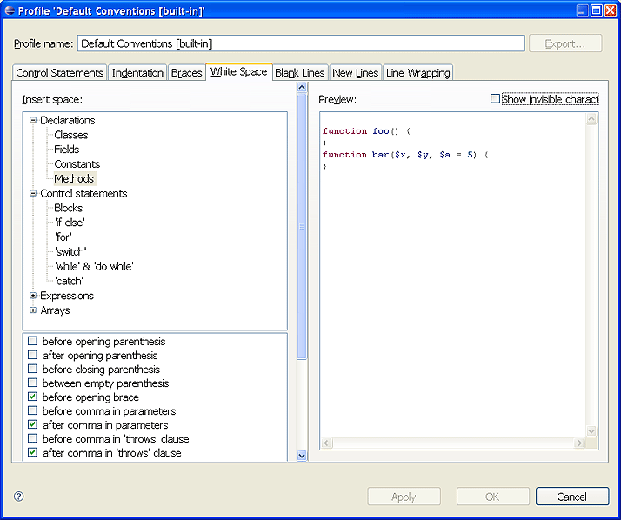

Path Mapping for Remote Debugging
Along with a few other debugger improvements, we've enhanced the PHP remote debugger with path-mapping capabilities. This enhancement should resolve most of the mapping issues that were exist in the previous debugger infrastructure.
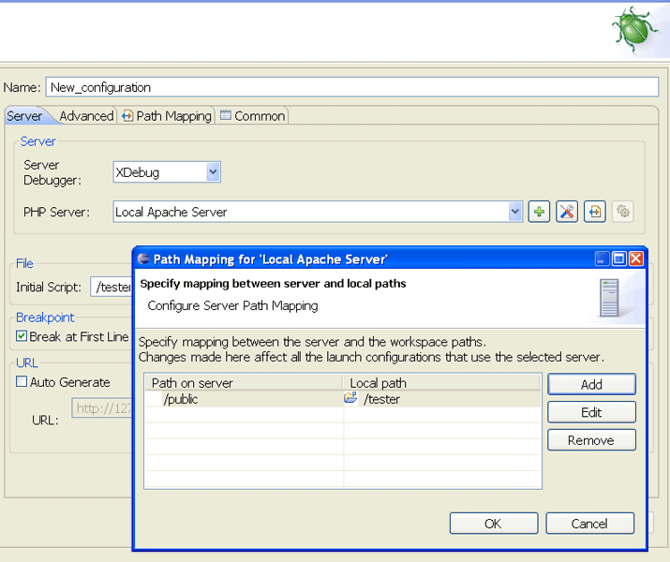

Type Hierarchy Viewer
The type hierarchy viewer is actually a set of views that can be accessible from the application menu and from the editor to provide a clear view of the class/interface hierarchy structure.
Clicking on a type in the editor and then selecting Navigate | Type Hierarchy from the application menu, will open the Type Hierarchy View.
The view displays the hierarchy for the type and allows you to toggle to the 'Super-Type' and the 'Sub-Types' hierarchies.
The bottom part of this view displays the selected type functions and fields.
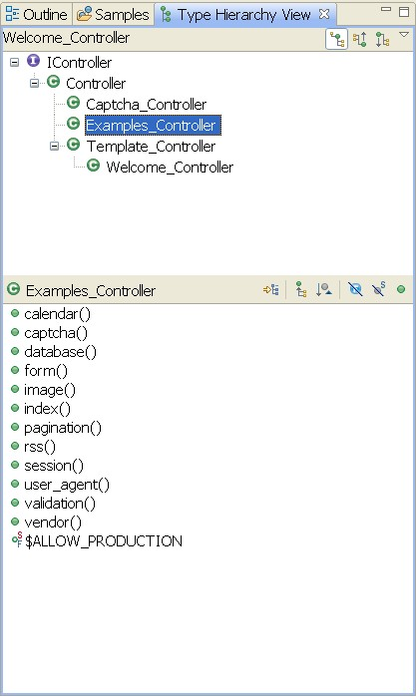
The second view in this set of type hierarchy views allows you to select any type that is accessible in your workspace for a view in the Type Hierarchy.
Select Navigate | Open Type in Hierarchy option to display the dialog for the type selection. The selected type will appear in the hierarchy.
You can also open this view by clicking the button on the toolbar, or by typing Ctrl+Shift+H.
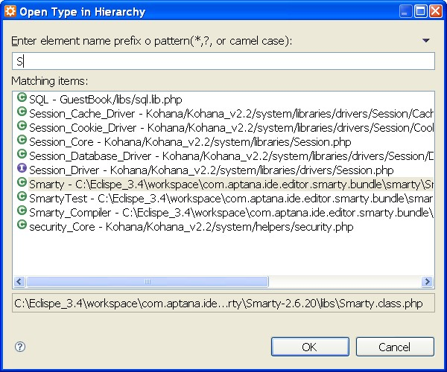
The third view is available through the editor: Click on the type that you wish to view and then type Ctrl+T (or click Navigate | Quick Type Hierarchy).
You can also toggle between the different tree views (just as with the Type Hierarchy View) by clicking the Ctrl+T again.
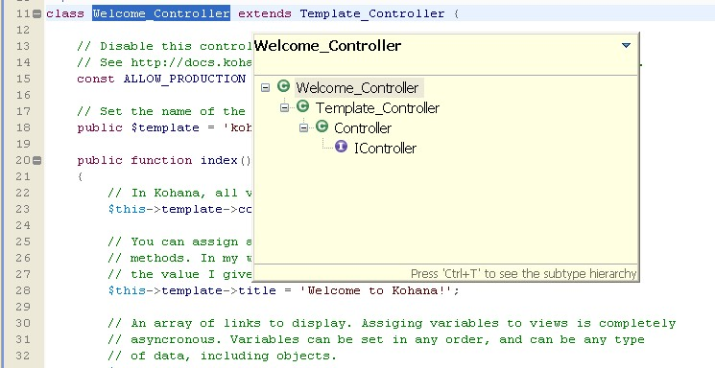

PHP Elements View
The PHP elements view provides a quick and enhanced view for all the PHP elements that are available in your workspace.
The view displays the elements by project, and is also capable of displaying elements that were added as PHP libraries in the workspace, and elements that are available in the PHP API.
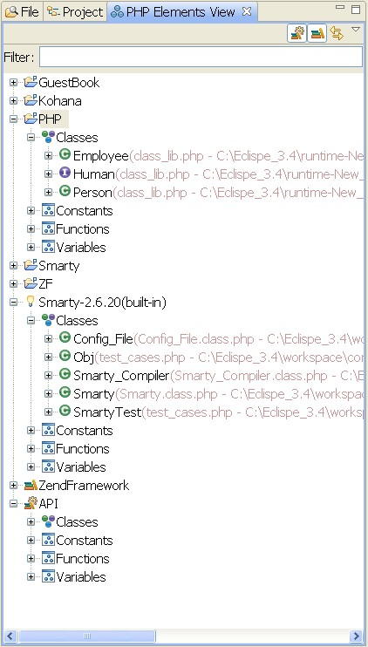
The view also allows to filter the elements that are visible in the tree by typing into the 'Filter' field.
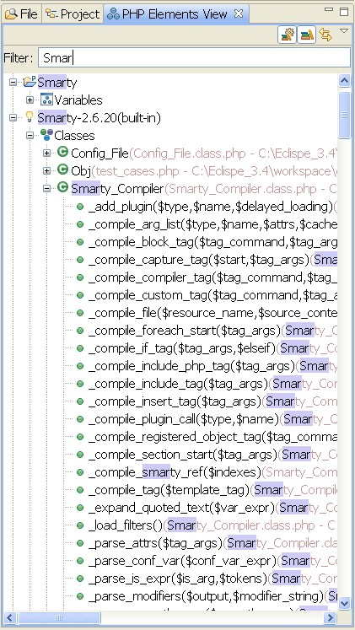

Mark Occurrences
Note: This feature is supported on Aptana Studio 1.2.6 and above.
Clicking on a variable, method, or type will mark all the referenced of this type in the edited script. The usages of that variable, method or type will be highlighted in a gray color, while the assignments for that variable will be marked in an orange color.
It's possible the toggle on and off the "Mark Occurrences" by clicking the toolbar button (), or by typing Alt+Shift+O.
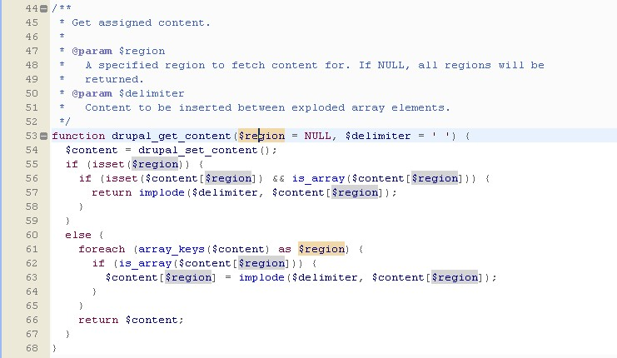

Override Indicators
The override indicators addition to the annotation bar provides a very powerful indication for any function definition in a class that is overriding or implementing a function from the class's hierarchy.
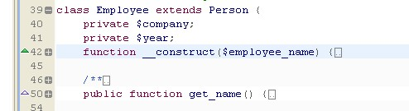

XAMPP Integration
The XAMPP integration allows adding an existing XAMPP installation as a PHP server. If you wish to do so, the added XAMPP will be patched to work with the remote debugger automatically.
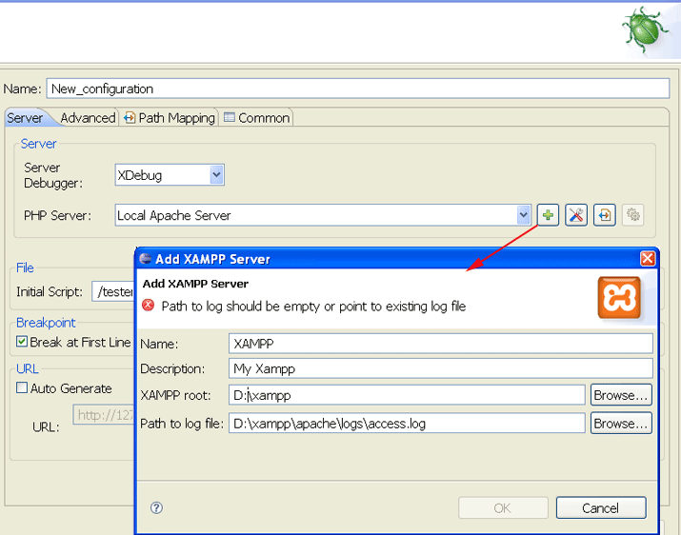
Retrieved from "http://www.aptana.com/docs/index.php/Aptana_PHP_Plug-In_1.1"
Category:

Configuring PHP Preferences

From Aptana

Contents
[hide]
- 1 PHP Editor tab
  - 1.1 Pair Matching
  - 1.2 Default Content
- 2 Code Assist
  - 2.1 Auto-activation
  - 2.2 Filtering
  - 2.3 Performance
- 3 Code Templates
  - 3.1 Available Actions
- 4 Colors: PHP
  - 4.1 Manage Colorization
  - 4.2 Editor Options
- 5 Colors: PHPdoc
  - 5.1 Manage Colorization
  - 5.2 Editor Options
- 6 Debug
  - 6.1 Allow multiple debug sessions
  - 6.2 Switch back to Aptana perspective when the debug is terminated
  - 6.3 Installed Debuggers
- 7 Folding
- 8 Formatting
- 9 PHP Interpreters
- 10 PHP Libraries
- 11 PHP Manual
- 12 Preview
  - 12.1 Preview Browsers
- 13 Task Tags
- 14 Typing
- 15 Validation

PHP Editor tab
- File Associations: Lists the file types that are opened using this editor
  - Edit: Make changes to the list of file types opened using this editor

Pair Matching
- Highlight Color: select a color for highlighted text
- Display options: (choose one of)
  - Do not highlight matching pairs
  - Highlight only matching element
  - Highlight entire pair
- PHP Editor Mode: (choose one of)
  - Tabbed: Source and configured previews are shown singly (DEFAULT)
  - Horizontal Split: Divides the editor window into horizontal slices, one for the source and each configured browser preview
  - Vertical Split: Divides the editor window into vertical slices, one for the source and each configured browser preview
  - Source only: No browser previews enabled
- Display HTML Toolbar: on/off

Default Content
- Default PHP filename: Suggested string used when you create a single new PHP file
- Create project file in new PHP project: Whether new PHP projects get an index.php file created in them
- PHP project file name: Name (default is index.php) used if the Create project file option is enabled
- Show content of simple PHP nodes in outline: on/off
- Initial PHP file contents: Defaults to the following but you may change it to a more complex code fragment
<?php
phpinfo();
?>
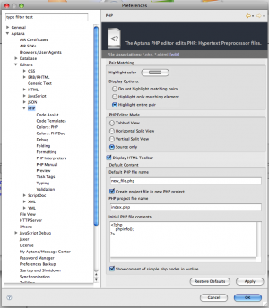
Main PHP Preference Panel

Code Assist

Auto-activation
- Automatically display code assist when typing: on/off
- Auto activate on identifiers: on/off

Filtering
One of:
- Assist only on explicitly referenced files: Uses only the current file and any specifically included files to offer suggestions (and will follow through to files included in those files as well)
- Assist on all files: Uses all files in the active project to offer suggestions

Performance
- Parse unsaved module on identifiers completion: on/off

Code Templates
Create, edit or remove templates that you use as keyboard shortcuts to insert more complex strings of PHP code. Templates can include placeholders for you to input context-specific elements.
The table lists the available shortcuts. Examples templates that come baked in are:
- you type -> gets inserted
- cln -> clone()
- itdir -> code to iterate over the files in a directory

Available Actions
- New: Add a template
- Edit: Change a template
- Remove: Delete a template
- Restore Removed
- Revert to Default: Change the entire list back to the version shipped with Studio
- Import: Add templates from a file
- Export: Save templates to a file
Import and Export are handy for getting your customized set of templates from one machine to another!

Colors: PHP

Manage Colorization
- Import: Add color rules from a .col file
- Export: Saves the current set as a .col file
- Override Eclipse editor settings: If enabled, the PHP Editor will use the color settings on this panel, otherwise it uses the Eclipse defaults colors.
Colorizer File Format details - very technical!

Editor Options
- Override Eclipse Options: Activates the rest of this panel's controls so you can customize the color set
- The remaining controls enable you to change the colors used for specific sections of code and language elements.
- Click any color button to open a color picker--the specific picker depends on your operating system.

Colors: PHPdoc

Manage Colorization
- Import: Add color rules from a .col file
- Export: Saves the current set as a .col file
- Override Eclipse editor settings: If enabled, the PHP Editor will use the color settings on this panel, otherwise it uses the Eclipse defaults colors.
Colorizer File Format details - very technical!

Editor Options
- Override Eclipse Options: Activates the rest of this panel's controls so you can customize the color set
- The remaining controls enable you to change the colors used for specific sections of code and language elements.
- Click any color button to open a color picker--the specific picker depends on your operating system.
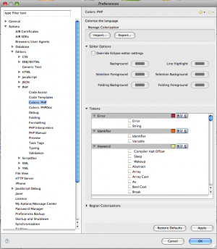
Colors:PHP Preference Panel

Debug

Allow multiple debug sessions
The debugger has the ability to run multiple, independent debugging sessions if you desire.
- Always: Starts a new debug session each time you start a debug session
- Never: Blocks new debug sessions if one is already running
- Prompt: If debug session is already running, asks you if you want to start a new one

Switch back to Aptana perspective when the debug is terminated
- Always: Automatically returns to the Aptana perspective
- Never: Remains in debug perspective
- Prompt: Asks to switch or stay

Installed Debuggers
We support debugging with both Zend and XDebug but only XDebug is supplied with Aptana Studio; to use the Zend Debugger you must install it separately and configure it on the Preferences panel.
Using either debugger requires an internal port to be open when Aptana Studio is open.
- Zend: Allows you to configure the port number to use
- XDebug Options:
  - port number
  - Show super globals in variable view: on/off
  - Max array depth: an integer
  - Use multi-session: on/off
Note: For XDebug, Aptana Studio verifies that the debug client port specified in php.ini and Aptana Studio preferences are the same.

Folding
- Enable folding: turn the feature on or off
The remaining options, if folding is enabled, determine the fold state of the specific block type:
- Initially fold functions
- Initially fold classes and interfaces
- Initially fold PHP code
- Initially fold PHPdoc comments
- Initially fold block comments

Formatting
- Format Preference Page: Choose from the default conventions, a set you added or imported, or none
- Show project specific settings link: Select project from list to set the text file encoding and new text file line delimiter.
- Clicking Edit allows you to specify formatting for various language elements such as spaces or tabs, new lines for control statements, brace locations and new line use.
- New lets you create a set of conventions, optionally starting from the default set
- Import adds a set of conventions from a file
- Remove is only available when a non-default set is active
- Restore defaults resets the conventions as shipped with Studio
The big text area that occupies most of the panel shows a preview based on the active settings.
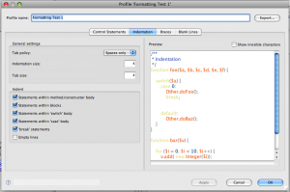
PHP Formatting Set Panel

PHP Interpreters
Lists the configured PHP interpreters; two instances (command line and CGI) using XDebug are configured by default by Aptana Studio.

PHP Libraries
Add a library path to your framework to get Code Assist for it in all PHP projects in your workspace. For example, to add the Zend Framework, you need to add the library folder of the framework (e.g., C:/ZendFramework-1.6.2-minimal/library/).
To turn off Code Assist for the library on specific projects right click a project and remove Code Assist (using the project's PHP Buildpath preference page).

PHP Manual
These settings determine what opens when you use the Open PHP Manual command in the PHP editor.
- URL of documentation site (default: http://www.php.net/manual/en)
- Add additional sites (or a local copy of the docs) using the New button, but only the default choice is used in Studio
- Change the default site by selecting your preferred site and clicking Default
- Open PHP manual in new browser window

Preview
- Automatically save editor when preview tab is selected: on/off
- Prevent caching of preview pages: on/off
- Preview Type: (select one of)
  - Sample URL
  - Use Server: Choose from Studio's built-in Apache server, any server you previously configured or add a new server
    - Append project name: on/off; always enabled for the built-in server, your choice otherwise
  - Use Run Configuration: Choose from an existing Run configuration or add a new one
  - Use absolute URL
    - Append project relative path: on/off
  - Use file URL: Opens the browser to a file::/path/to/file/filename.extension URL

Preview Browsers
- Set the browser previews that will be used with files opened in the PHP editor
- This is OS-dependent
- Default choices are from Internet Explorer, Firefox, Safari (OS X only) and iPhone
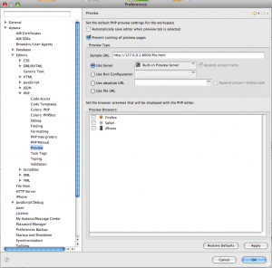
PHP Preview Preference Panel

Task Tags
Tasks are shown in the Tasks view.
- List of strings (name, priority, is default for each) indicating a PHP comment should be interpreted as a Task
- Configure project specific settings link: Select a project from your list to have certain tags treated differently (or be recognized at all) in that project. A use case is that you're part of a team for a given project and the team uses task tags that you do not want to be part of for other projects. Examples:
  - the priority for TODO is high but todo is normal
  - the project lead uses team member names in all caps to show who owns the todo (meaning each team member's name is a task tag)
- Case-sensitive task tag names: Treat TODO and todo as the same or different

Typing
Auto-insert matching characters:
- Don’t auto-insert
- Auto-insert
Choose what happens when you type an opening block delimiter (such as a brace, quote, bracket, etc.)

Validation
- Validators: Use the embedded PHP Syntax validator or not
- Filter for Validation View Errors: A list of regular expressions to filter from the validation view. By default this list is empty.

Basic PHP Debugging

From Aptana
These are the basic instructions for starting a debug session.
There two types of debugging
- internal debugging (e.g. Script debug)
- Web Page debug, which uses a debugger extension (either Zend or XDebug) installed on a server

Contents
[hide]
- 1 Script debug sessions
- 2 Web page debug configuration
- 3 The Debugger
- 4 Debug Ports
- 5 XDebug Configurations

Script debug sessions
These can be initiated in a several different ways.
First:
- Right click the editor area and select 'Debug As'->'PHP Script'.
- You will be prompted to move to the debug perspective - Click yes.
- In that perspective you will see the debug stack, variables and breakpoints views. You can also add more views, like the Watches view.
- From here you can do a step into, step over and step return by clicking the buttons on the stack view or by using F5/F6/F7 keys.
- You can set more breakpoints as you debug, or even run to a line that you mark (right-click + 'Run to line' action -> Will be available soon).
The second way you can run a script (the one currently active in your editor):
- Click the bug-shaped button on the application toolbar.
- Hit the 'arrow' to select PHP CGI or PHP CLI execution.
The third way is to hit the same debug arrow as above and select Open debug dialog. A dialog will be opened, in which you can create new PHP Script debug configurations and then launch them.

Web page debug configuration
This can be setup only through the debug dialog.
Open the dialog and add a new configuration for a "PHP Web Page".
To complete such a configuration you have to set up a server (through the Servers view) such as Apache or XAMPP.

The Debugger
The Studio debugger works with the Zend and XDebug extensions, and they can be controlled through a Preference:
- Windows -> Preferences -> Aptana -> Editors -> PHP -> PHP Interpreters, and then edit the default interpreter.
The default interpreters that we bundle contains a pre-configured XDebug extension; to use Zend you have to manually add it to that dialog and then select Zend as Debugger Type.

Debug Ports
There are two debug port that the studio opens when loading.
Port 9000 for the XDebug debugger and port 10000 for the Zend debugger.
These ports can be controlled through a Preference:
- Windows -> Preferences -> Aptana -> Editors -> PHP -> Debug

XDebug Configurations
The Studio debugger bundles a XDebug debugger with a pre-configured php.ini. However, if you wish to define your own XDebug setting you'll have to make sure that the minimal required settings for a session initialization are set in your ini.
zend_extension_ts=<debugger path>/php_xdebug.so
xdebug.remote_enable=1
xdebug.remote_host=127.0.0.1
xdebug.remote_port=9000
Note: Port 9000 is the default port for XDebug. In case the Aptana PHP debugger client is set to listed on port 9000, there is no real need to set it in the ini, however it's a good practice to do so.
In case that an XDebug session is triggered from the studio and the client port does not match the debug port defined in the ini, the Studio will prompt you about it and advise you what to do.

